# Week 10 Homework

1. Utilizing one of the free Rendering Apps in the App store, create several photorealistic renderings of the Mini Chopper Gear Assembly for a “Marketing Brochure”:

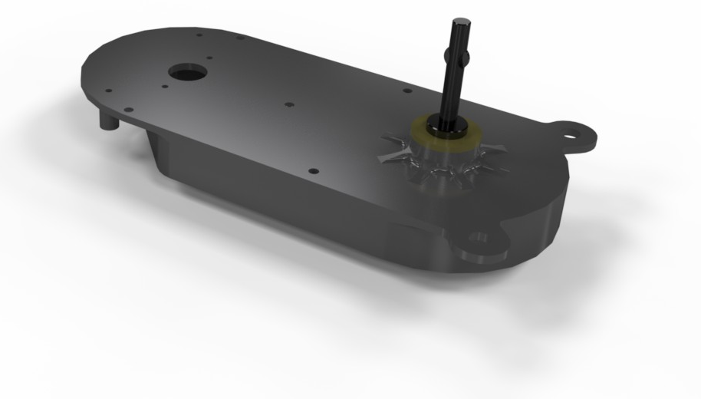 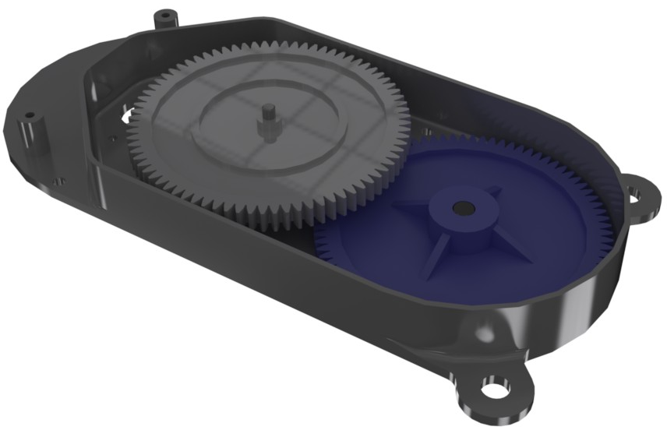

1. The following Onshape Assembly has been created, such that each of the 1” long, ¼”-20 screws are fixed in place, and pointed towards the origin. Using the Hole Feature, locate and create the proper holes to prevent interference. Hint: Utilize the “translucent” view option to check for interferences, as shown below. CAD model [here](https://cad.onshape.com/documents/808c7aed719a892f8ff3d8f9/w/11e0a51e4c6e3148d5d89c45/e/fe3b9019fc9e051990830726) and screw dimensions down below:
   1. Left - A simple blind tapped hole for the Button Head Screw
   2. Center - A counterbored through hole in Part 1 (top) and a blind tapped hole in Part 2 (bottom) for the Socket Head Cap Screw
   3. Right - A countersunk blind tapped hole for the Flathead Screw, make sure the countersink is large enough so the screw will actually sit flush (i.e. there is no interference).

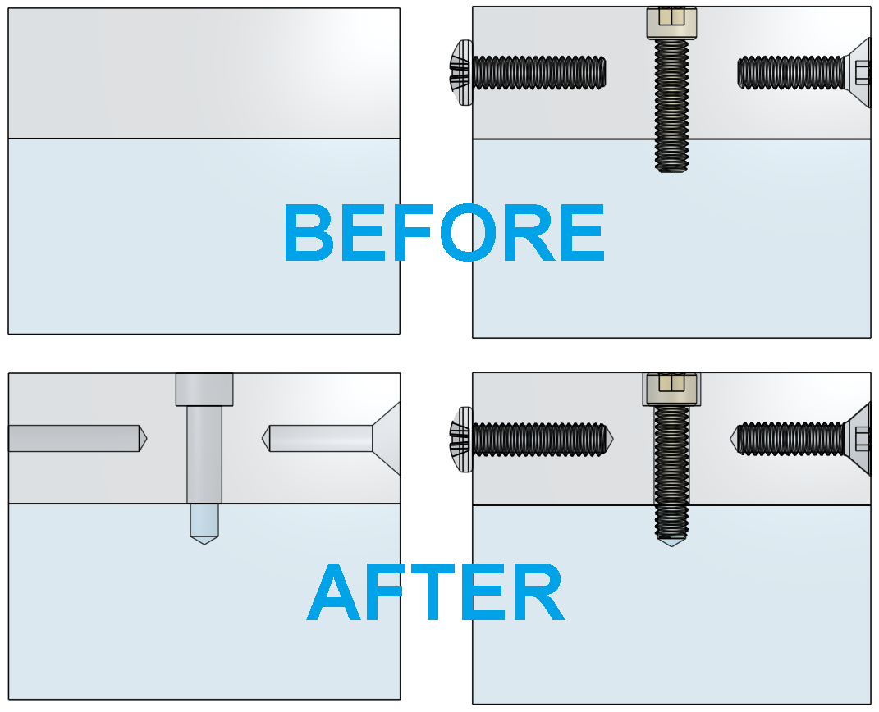

Here are some important screw dimensions:

